Second Project

TRS (Tourist Recommendation system) is a website that allows user to search holiday packages on their need like…

Family package, Honeymoon Package, Holiday Package, Hotels, Holiday Themes (Seasonal Packages, Adventure, Family, Nature, Honeymoon, Wildlife, Friends, Water Activity, Religious e.t.c)

User are also allow to search their Plans on the basic of 4 Filter option—

1. Destination
2. Budget
3. Duration
4. Months

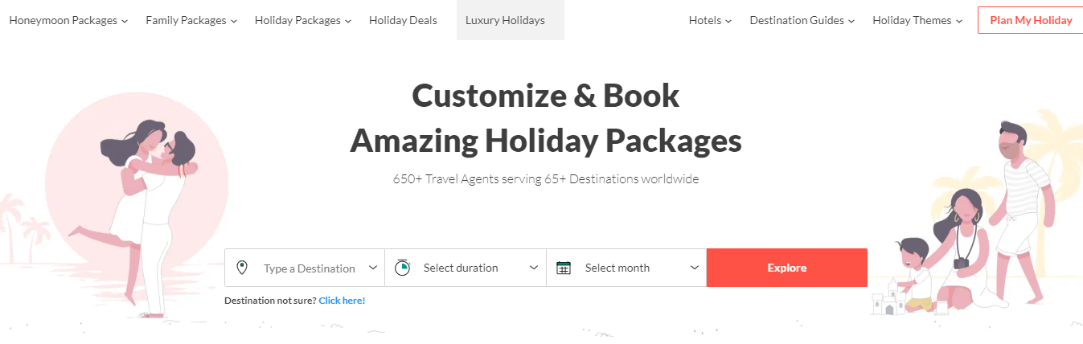

Now these are the some sample of project themes ---

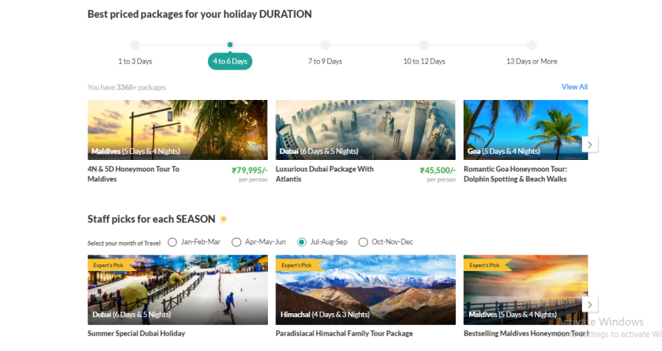

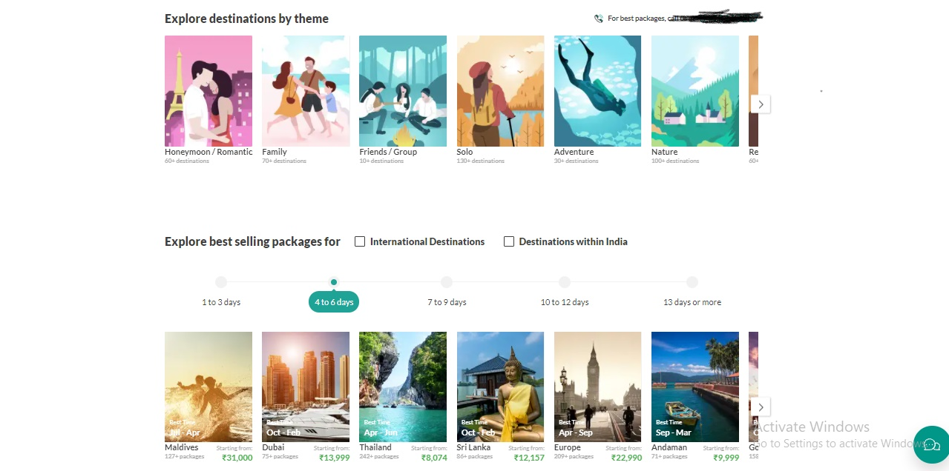

Technology used—

**Front-end**

HTML

CSS

Bootstrap 5

JavaScript

React

**Backend**

Node Js

MongoDB

Functions/ Features –

1. Login /Sign up
2. Option for selection packages
3. Filter option for better and short result
4. Packages in also available on their mode (honeymoon, family, business, friends etc)
5. Hotels are also available on state bases over all country.
6. Packages are available on hot deal.
7. Etc

Prepared by--  
Aman Anand

Full stack development with Edureka.